Creating a Web-GIS application for Prehistoric Hand Print Caves Inventory in Unesco Global Geopark Maros Pangkep Geosites, Indonesia

Imran Ilyas¹, Ilham Alimuddin² Yadi Mulyadi³

¹Research and Innovation National Agency
Cultural Preservation Office of Region IX
Email: imranilyas2023@gmail.com

²Lecturer, Geology Department, Hasanuddin University,
Faculty of Engineering Gowa Campus, Jl. Malino no 8F
Email: ialimuddin@gmail.com

³Lecturer, Archaelogical Department, Hasanuddin University,
Faculty of Engineering Gowa Campus, Jl. Malino no 8F
Email: yadi.mulyadi@unhas.ac.id

KEY WORDS: Prehistoric Hand Print Caves, Inventory, Web GIS, Global Geopark, Maros Pangkep

ABSTRACT: This research was conducted to support the easy and fast dissemination of information in the network (online) by building an effective and efficient information system. The main data used is the fixed coordinates of prehistoric sites in the UNESCO Global Geopark Maros Pangkep Karst area. The purpose of this research is to build a database of potential prehistoric caves in the Leang Leang Sub-Area and Lopi Lopi Sub-Area that can be updated and to formulate a form of information system that can be used as material for data analysis related to threats, decision making in terms of conservation policies, as well as further research. This research also aims to create GIS Web-based maps that can be accessed online. This research has significant benefits, including the creation of a database of prehistoric caves that can be updated regularly. Through the development of a GIS Web-based information system, it is hoped that this application will facilitate the dissemination of information regarding the potential of prehistoric caves to the public, researchers and other related parties. This information system is also expected to be the basis for decision making in conservation policies and further research in the Maros-Pangkep Karst area. With a centralized and easily accessible information system, it is hoped that the public will be able to obtain complete and accurate information regarding the potential of prehistoric caves in the area. In addition, GIS technology also provides new opportunities for archaeologists to analyze data collected in the field, thereby encouraging the development of more explanatory disciplines through quantitative approaches and spatial/statistical analysis. The implementation of the information system resulting from this research can be used by the Cultural Conservation Agency on an ongoing basis.

Introduction
Located in the south arm of Sulawesi Island, Unesco Global Geopark Maros Pangkep (UGGp) is across by the Wallacea Line at the coordinates of 118 ° 54'25.0 "E - 119 ° 58'22,6" E and 4 ° 25'21.0 "S - 5 ° 12 '41, 3 "S. Located 30 km from Makassar City (1 - 2.5 hours), geopark territory of 5,077.25 km² area stretches from land to the ocean. With an elevation of 0 - 1300 masl, this area is dominated by tower karst clusters. The mountainous area is located in the northeast, with the highest peak represented by Bulusaraung Mountain (1,353 masl). The western and southern sides are dominated by hilly areas. The rest is in the middle to the east in the form of lowland and archipelago areas with the farthest island on Kapoposang Island (± 40 miles). The climate is divided into 2, namely Type C2 which is relatively dry in the west, and Type B2 which is relatively wetter in the east. In this area, there are also Bantimurung Bulusaraung National Park on the mainland and the Kapoposang Water Tourism Park in the ocean part, as a whole, there are 1,437 species of flora and fauna with 153 endemic species of Sulawesi and 52 protected endangered species. The prehistoric caves spread across the Karst of Maros Regency and Pangkajene and Islands Regency (KKMP) are the nation's cultural treasures, as stated in the Cultural Heritage Law Number 10 of 2011 (UU CB No. 11. 2010). These prehistoric caves can be designated as cultural heritage as a form of human thought and behaviour, because they have potential and significance for the understanding and development of history, science and culture in life. Because cultural heritage is considered important, it is necessary to make efforts to preserve and manage it appropriately through efforts to protect, develop and utilize it in order to advance national culture so that it can be used as much as possible for the prosperity of the people.
The Archaeological Potential in the Maros Karst Area has been widely revealed, until now the focus of research activities and preservation activities is still continuing, this is because prehistoric cave images (rock art) have become real objects and become benchmarks for human civilization in the Maros Pangkep Karst Area, results dating prehistoric images in Leang Tedongnge which are known to have existed since 45.5 thousand years ago (Brumm et al., 2021). The results of this research are in sync with the results of previous research in Leang Bulu Sipong 4 (Aubert et al., 2019) and in Leang Timpuseng (Aubert et al., 2014). The revelation of the age of prehistoric drawings in caves in the Maros-Pangkep Karst Area is a source of wealth and pride that needs to be conveyed and maintained from generation to generation.

Figure 1. Map of Unesco Global Geopark Maos Pangkep (source: UGGp Maros Pangkep website).

The Leang Leang and Lopi Lopi Sub Areas are named after the results of a delineation study carried out by the Makassar Archaeological Heritage Conservation Center (now the South Sulawesi Provincial Cultural Heritage Conservation Center, hereinafter abbreviated as BPCB Sulsel) in 2011. The purpose of making the delineation is to unite prehistoric cave sites that are limited. by space so that it becomes a region, the estuary is the determination of sub-regions that have been made into cultural heritage areas, the delineation carried out by BPCB South Sulawesi is a follow-up to zoning activities that have been carried out previously (anonymous, 2011:48-50).
The Leang Leang sub-region is found in the Tompobalang karst hills which stretch from the south to Bulu Pute to the north, which includes the valley plains to the west which are used as residential areas and rice fields. (Anonymous, 2019:1). Meanwhile, the Bulu Sipong sub area is a single hill located in Pangkep.
Based on data compiled by the South Sulawesi BPCB in 2022, the number of prehistoric caves in the Maros-Pangkep Karst Area is 574, 332 of which are in Maros Regency. (Anonim, 2022). In particular, the number of prehistoric caves in the Leang Leang Sub Area is 24 caves and the Bulu Sipong Sub Area is 8 caves. The archaeological potential found in these two sub-regions includes prehistoric caves and their remains, but it cannot be denied that there are other potentials that can be exploited, namely biodiversity potential and geological potential.
Representing site distribution point data using a geographic information system is better using polygons, this is because polygons (areas) can represent the dimensions of sites that have different size areas. (W.Mehrer & L.Wescott, 2006), creating a site area in this case means describing the cave not just in point form, but displaying it in plan form in polygon form. This can be done using the georectification method or coordinating all existing cave plans, then displaying them on a sub-regional distribution map.
The karst area in Maros Regency and Pangkep Regency reaches ± 46,200 Ha (Ahmad & Hamzah, 2016, p. 7), so it is very possible to increase the amount of data regarding the potential for prehistoric caves in this Karst Region in the future. Therefore, to anticipate the increasing amount of data, the provision of a sustainable information system as soon as possible must be planned. The main data that constitutes the prehistoric cave point is spatial data and has a geographic information system, so data processing requires an application that can accommodate various data so that it can produce information that is integrated with various needs.
The availability of data in agencies that handle cultural heritage preservation, in this case the Regional XIX Cultural Conservation Center, is still in the form of a geographic information system (GIS) based database, the data has tabulation and shapefile (.shp) formats which have not been properly maximized. In its development, GIS technology is expected to provide new opportunities for archaeologists to analyze data collected in the field, thus encouraging a shift in scientific discipline to become more explanatory, by adopting quantitative approaches and spatial/statistical analysis in the study of settlement patterns and site patterns/forms (Dell’Unto & Landeschi, 2022).
This is related to data that has not been published properly because there is no appropriate container or platform to accommodate spatial and non-spatial data in one place. Without a centralized and easily accessible information system, it is difficult for the public, researchers or other related parties to obtain complete and accurate information regarding the potential of prehistoric caves in the Maros Pangkep Karst Area. This can hinder appropriate decision making in the management and potential development of prehistoric caves. Information about potential prehistoric caves may be spread across different sources and data formats, such as geospatial data, archaeological data, and other related information. Coordination and integration of this data is important to present comprehensive and accurate information in a Web GIS-based information system. Moreover, the potential for prehistoric caves in the karst areas of Maros and Pangkajene Regencies and the Islands can attract tourism interest. However, challenges in sustainable tourism management may also be a problem. A wise approach is needed in promoting tourist visits, while preserving the caves, and paying attention to the social, economic and environmental impacts that may occur.

Research objectives
Spatial-based data relating to archaeological resource management in the Maros and Pangkep Karst Prehistoric Cave Areas is abundant. By utilizing existing data, in this research an effort will be made to embrace and combine various kinds of data that are available so that they can be packaged as a information systems, more details The objectives to be achieved in this research are as follows:
1. Building a database of potential prehistoric caves in the Leang Leang Sub Area and the Bulu Sipong Sub Area which can be updated at any time;
2. Formulate a form of information system that can be used as material for data analysis related to threats, decision making regarding conservation policies, as well as further research.

Research method
The idea of drawing and placing the results of field observations on maps has been around for a long time, archaeologists have used this idea to graphically represent the results of field surveys or excavations (Adkins & Adkins, 1989 in Dell’Unto & Landeschi, 2022: 6). This is in line with various kinds of research activities and studies of archaeological objects in the Maros-Pangkep Karst area which have map output, presenting information on prehistoric caves, generally using a raster format whose final results cannot be modified, even though the processing results consist of layers. vector-based data layer processed through a geographic information system technology platform (GIS-based software).
The crucial problem faced when displaying a map of the distribution of prehistoric caves in the Maros-Pangkep Karts area as a whole (574 sites) in analog form is, the accumulation of site points and labels for each object, this accumulation causes the loss of the essence of information regarding the location of the site and the name of the site. The only way to display the map analogously is to enlarge the map layout paper, so that the map scale can be reduced and the map layer symbols can appear clearly. This problem can be solved by designing (layout) the map using large size printing paper, for example A0 (124.49 x 89.99 cm), but it will not be efficient if printed, and certainly not practical if taken to the field.
The concrete solution to overcome this problem is to design Web GIS-based maps that can be accessed online. Web GIS capabilities provide a new paradigm on how to access and use geographic information anywhere, as long as it is connected to the internet. Finally, there are obstacles related to the accumulation of symbols and object labels (Esri, 2013) on map will be solved.
In this study, the research objects used as samples were the Leang Leang Sub Area located in Bantimurung District, Maros Regency and the Bulu Sipong Sub Area located in Minasate'ne District, Pangkajene and Islands Regency.
Before starting to create an information system, it is important to identify the type of data needed to achieve the system's goals. This involves understanding what information needs to be collected, processed and displayed in the system. This identification will help in designing appropriate data structures and determining the methods required to process the data. After data needs are identified, the next step is to design the database that will be used in the information system. This design involves determining entities, attributes, and relationships between entities in the database. The methods used in database design must consider efficient data structures, data integrity, and the system's ability to meet user needs.
Data is needed to build information systems while the methods used for data collection can vary, including surveys, automated data collection, or integration of data from external sources. Once the data is collected, appropriate storage methods must be implemented to ensure the data is available in an efficient and structured manner in the information system.
The methods used to process and analyze data are very important in information systems because they involve the use of algorithms, statistical techniques, or other appropriate approaches to generate information or insights from existing data. This method should be selected based on the type of data, analysis objectives, and user needs.
Data often comes from many different sources or modules. Data integration methods are used to combine data from different sources into one integrated data set. It allows information system users to access and manage data centrally, thereby facilitating better decision making.
Data presentation and visualization methods are important to facilitate understanding and use of information produced by information systems. These methods may include graphic displays, graphs, maps, or reports that are easy for users to understand. The use of effective methods for data presentation and visualization will increase user engagement with the information system.
In order to realize the creation of a successful information system, a good understanding of the required data, as well as the application of appropriate methods to collect, manage, process and analyze data is important. Good quality data and appropriate methods will provide a strong foundation for an effective and efficient information system.

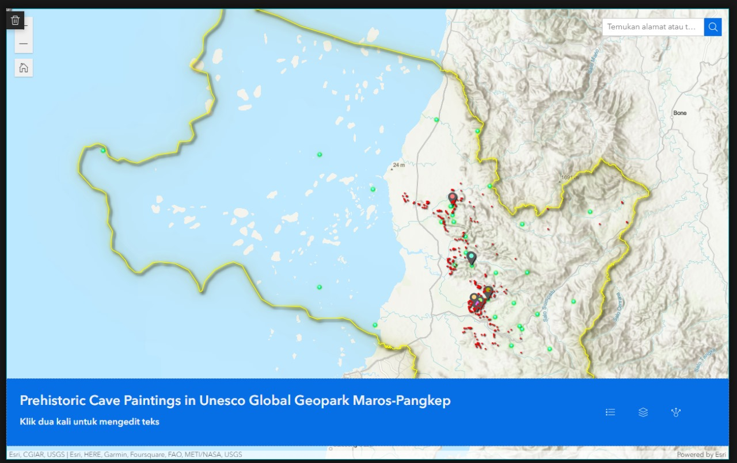
Figure 2. Prehistoric Cave Paintings in Unesco Global Geopark Maros Pangkep

Data collection
The initial effort to realize this research was by collecting data, both sourced from physical library materials ( hard copies ) and other library materials in digital form ( soft files ). The primary data used is spatial data sourced from the results of the activities of the BPK Region XIX agency in the Maros-Pangkep Karst Area. Spatial data refers to data related to geographic location or space. This data includes information about geographic coordinates, territorial boundaries, distances, and other attributes related to physical location. Spatial data is used in geographic information systems (GIS) to map, analyze, and understand spatial relationships between objects or phenomena in the real world (Lock & Pouncett, 2017).

Data classification and verification
Based on its type, spatial data is represented in 2 main formats used to store and manage geographic or spatial information, namely Vector and Raster formats.
1. Design of a potential information system for prehistoric caves using the Arcgis Online platform
2. Implementation of a prehistoric cave potential information system with various types of data
3. Identify data that can be disseminated to various segments
4. Preparing a portal to accommodate and present data virtually online.
5. Data presentation.

Research data
Data context refers to the structure and relationships within the data and how the data is collected, processed, used, and understood within an application. Data only becomes useful and has value as information when placed in the right context. For example, data about atmospheric conditions is recorded by meteorological stations around the world. However, the raw data is not directly useful. Useful information, such as a weather forecast that helps decide whether to bring an umbrella today, is generated through modeling and analysis of raw data from various sources. In this context, information can be defined as "data plus information context". In this process, data is processed and analyzed to produce useful information. It is important to understand the difference between data and information, because human knowledge of the world and decisions to act are based on information generated from data (Worboys & Duckham, 2004, p. 20).
Information updates also need to be carried out, along with current developments in information technology, the need for and access to information also increases and develops,

Collection of old information
In general, there is a lot of spatial data available at government agencies, especially at the Region XIX Cultural Preservation Center, but this data has not been fully managed optimally, so the information produced from existing data is only in the form of analog maps printed on paper. or in digital file form (.jpeg or .pdf). Overall, the data managed in this research comes from the results of the activities of the Region XIX Cultural Preservation Center, related to prehistoric caves in the Maros-Pangkep Karts Area. The method used to realize this research starts from data collection to presenting the data in WEB form GIS.
The number of prehistoric caves in the Maros-Pangkep karst area makes it impossible to collect data in a relatively short time, so it is necessary to limit the location in carrying out this research, therefore the Leang Leang Sub Area and the Bulu Sipong Sub Area are considered to represent the entire area because of the area of the area. have various regulations. The Leang Leang Sub Area consists of 20 prehistoric sites that represent the interests of tourist attractions, which also have regulations as the Bantimurung Bulusaraung National Park Conservation Area, apart from that, one of the Leang Leang sub areas is used as a Geosite by the Maros Pangkep Geopark Management Agency. Meanwhile, the Bulu Sipong Sub Area consists of 8 prehistoric sites which have limited access for general visitors and are included in the PT Semen Tonasa mining concession, and also represent locations within the mining concession even though they have been made into Biodiversity Conservation Areas (Kehati) by PT. Tonasa Cement.
The main data used in this research are fixed coordinate points of prehistoric sites in the Maros Pangkep Karst area, this later became the basis for selecting research locations, the Leang Leang Subregion in Maros Regency and the Bulu Sipong Subregion in Pangkep Regency are the 2 locations that have been has a fixed coordinate point, the coordinate point is represented by a concrete pillar installed in an open area around the site, the pillar coordinates are defined through a static measurement method using a dual frequency Geodetic GPS type South S86S, the results of the coordinate measurements are then used as a reference for measuring the coordinate values on each site datum point (DP) using a Total Station, each prehistoric cave in the Leang Leang and Bulu Sipong Sub Areas also has its own site DP which is also made of benton, apart from that, to maintain the accuracy of measurements, 1 or more more are made auxiliary coordinates to direct the TS instrument to certain coordinates (BS Data) as a reference point for TS orientation, BS Data is represented by markings made from anchors/ dynabolts which are planted using a drill in the limestone on the surface of the cave floor.

Archaeological Resources
Bulu Sipong Sub Area
Sites in the Bulu Sipong Sub Area consists of 8 prehistoric sites that have been recorded, there are 2 categories of sites, namely those with pictures and those without pictures, the sites with pictures are 5, namely Leang Bulu Sipong 1, 3, 4, 7, and 8. While the sites not pictured consists of 3, namely Leang Bulu Sipong 2, 5, and 6.

1. Leang Bulu Sipong 1
Astronomyically, the Bulu Sipong Cave is located at 4⁰ 48' 18.7” South Latitude 119 ⁰36' 33.4” E, precisely on the north side of the foothills of Bulu Sipong Hill. This cave has two floors arranged vertically, the first floor is included in the medium-sized cave category, located to the north-northwest of Bulusipong Hill facing the cave mouth is an azimuth of 340⁰ . Width size 12.5 meters, 8.3 meters high and 24.2 meters deep. Getting to this cave is quite easy because there is road access in hardened condition so you can use two-wheeled or four-wheeled vehicles, approximately 100 meters from the foot of Bulusipong hill and then through the bushes. until it reaches the mouth of the cave in the lowlands as a foothill at a height of 16 meters from DPL.
At the beginning of November (7-13) 2016 there were excavation activities by opening 3 excavation boxes carried out by students from the Archeology Department, Faculty of Cultural Sciences, UNHAS as field practice. The condition of this cave now looks unkempt where there are still remains of stakes and stretches of rope as well as modern rubbish. Regarding the condition of the cave wall paintings, most of them are peeling/curved and the color tends to be blackish red
The justification for this cave as a former prehistoric residence is the presence of a negative hand image ( 3 clear fingers remaining ) with light brown coloring on the ceiling , precisely at the end of the stalactic in the center of the cave. Apart from the cave wall paintings, there is also a deposit of mollusk shells 60 cm thick on the left side of the cave wall, while pottery fragments and several stone artifacts are visible on almost the entire cave floor.
The second floor is above the first floor with a height of about 9 meters from the ground or cave courtyard. This floor can be reached in two ways, namely by tracing the north side of the cliff from the left of the cave mouth with a slope of about 10 to 20 degrees and climbing through the hole there. on the first floor ceiling with a slope of about 90 degrees.
The orientation of the mouth of the cave faces North West (325 ⁰) with a width of about 4.7 meters and a height of about 5 meters, this floor consists of two rooms, the first room facing the front with a fairly high intensity of light and the second room is in the interior with non-existent light intensity. The first room is in the form of a hall with a length of about 12.5 meters, a width of about 7 meters and a ceiling height of about 5 meters. The surface of the cave floor is uneven, most of the floor consists of limestone, in the middle of the cave there is a hole measuring 2.5x1.6 cm that connects the first floor with the second floor.
In the interior of the first room there is a small hallway with a width of around 50 cm and a height of around 1 meter. This hallway is the access to the second room with a length of around 6 meters. The second room is in the form of a hallway that extends to the northeast with a width of around 3 meters. and the ceiling height is around 5 meters, the hallway is quite long and penetrates all the way to the Bulu Sipong 2 cave. The condition of the room is still active so in this room you can find many cave ornaments such as stalagmites, stalactites and water pools. This room has no light intensity so the room is very dark and damp, the surface of the cave is uneven and most of the floor consists of limestone, the outer surface is lower than the inner surface with a slope of about 10 degrees .
The potential cultural heritage contained in this cave is wall paintings and pottery fragments. The wall painting consists of two panels positioned on the right side of the cave wall. The condition of the first panel has been damaged due to weathering of the main stone so that the painting is difficult to identify in terms of shape and type, the condition of the second panel has also been damaged but in this painting there are still recognizable shapes so that it can be concluded that the painting is a painting. Tagan palms are generally found in caves in Maros Pangkep.
Findings in the form of pottery shards were also found on the surface of the cave, but there were not many, only consisting of a few shards identified as parts of the body and edges, these shards had no motifs (plain), were quite rough porous with a blackish brown color.

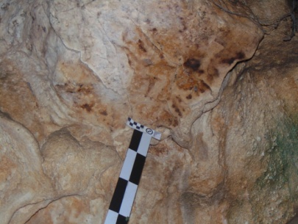
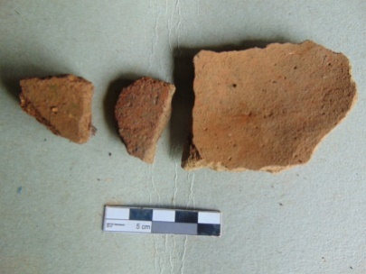
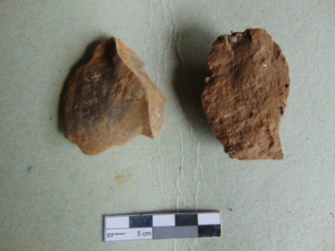
Figure 3. Left. Wall Painting, Centre. Ceramics, Right. Slate

2. Leang Bulu Sipong 2
Leang is included in the cave category, located to the north of Bulu Hill Sipong is in the astronomical position of L S 4⁰ 48' 19.2'' 119⁰ 36' 34''.6 BT, facing the mouth of the cave northeast or 120 NE. The dimensions of the door are... width, height... and depth... it has a narrow passage and a dark space. Its condition is damaged due to stone-taking activities by the local community. On the cave floor, the center of the cave appears to be strewn with charcoal and ash from burning to make it easier to break rocks. Meanwhile, the ceiling of the middle cave appears black as traces of burning smoke. On almost all parts of the wall that might protrude, there were traces of pruning so that all over the cave floor you could see stone fragments strewn about.
An indication that shows that this cave was once a residential area is the discovery of 4 pieces of pottery shards.
Regarding the cave wall paintings, nothing has been found at this time. The position of this cave from the foot of the hill is around 20 meters or perpendicularly reaching a height of 16 meters. To reach this cave, simply climb manually from the left of the cave mouth along a rocky slope interspersed with soil, grass and trees. The vegetation in front of the cave consists of teak trees

3. Leang Bulu Sipong 3
Astronomically, the Bulu Sipong Tiga Cave is in position 4 ⁰ 48' 22.0'' South Latitude 119 ⁰ 36' 35.9'' E, precisely on the east side of the foothills of Bulu Sipong Hill, which is a combination of a niche and a cave with the position of the cave being at the foot of the hill and the niche. is on the right side of the cave at a height of 16 meters from the ground or cave courtyard.
The orientation of the cave mouth faces southeast (22 ⁰ ) with a width of 8.6 meters and a height of 7 meters. This cave is in the form of a passage leading to the northwest and the inner body turns to the southwest. The overall length is around 17.7 meters and the width is around 7.8 meters. The surface of the cave is uneven, the outside is higher than the inside with a slope of around 10 degrees, on several sides there are boulders with bolder sequences, to be precise on the outside, middle and inside. The light intensity at the front is lacking and at the inside there is none at all so the cave is damp and dark, and on some of the cave walls there are moss plants.
This niche has two doors, the first door is to the left of the niche with an orientation towards the North East (60 ⁰) with a width of 4.2 meters and a height of 3 meters, the second door is to the left of the niche with an orientation towards the Southeast (32 ⁰) with 1.6 meters wide and 2 meters high, this niche is semi-circular in shape where in the middle and front there is a pillar that separates the first door from the second door, this niche is not too wide with a width of 3 meters, a length of 3.5 meters and a ceiling height of 2.5 meters, the light intensity is very good and the cave surface is quite flat.
The archaeological potential contained in this cave is only in the form of paintings found in niches. The condition of the paintings has been damaged due to weathering that occurred on the container or core stone so that the shape and type cannot be identified. The paintings are on the left side of the ceiling and sky. -ceiling on the inside. The only finds in the
cave were a scattering of new bones, while there were no finds with archaeological potential in the form of paintings or other remains such as stone tools, kitchen waste and pottery.

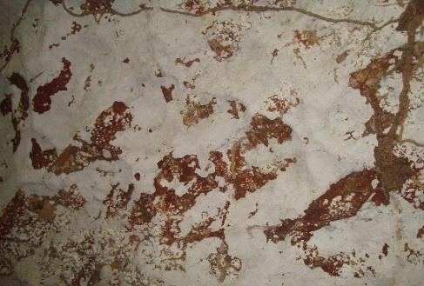
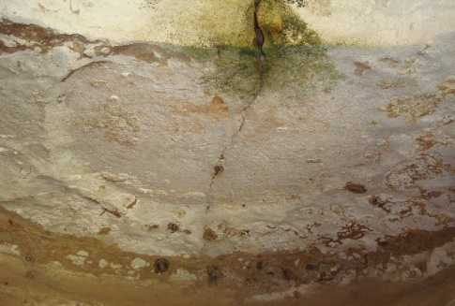
Figure 4 : Left Photo Painting on the Inner Wall, Right Photo . Panting on Left Ceiling

4.Leang Bulu Sipong 4
Astronomically, the four Bulu Sipong Caves are located at 4⁰ 48' 24.5'' South Latitude 119⁰ 36' 36.3'', precisely on the east side of the foothills of Bulu Sipong Hill, this cave has two floors which are arranged vertically, the first floor of Leang is in the cave category because there is a side dark in 5 rooms, 3 terraces and 4 large cave mouths. To reach this cave, you should find the easiest access by going through the main door on the right side, which is the lowest floor of the three other cave mouths with a height from the foot of the hill of approximately 22 meters. or 36 meters from DPL
To identify the position of each painting, spatial division is used starting from the right side of the cave. Please note that at the rightmost cave mouth there are 2 chambers, then at the middle cave mouth there is 1 chamber, likewise at the left cave mouth and the upper cave mouth each only has 1 chamber.
In room 1, namely in the right room of the cave, there are 8 random negative handprint paintings on the cave ceiling which are still clear , apart from that there is 1 panel whose painting cannot be identified.

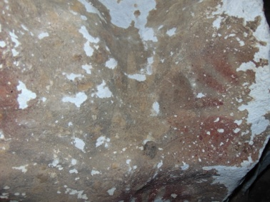
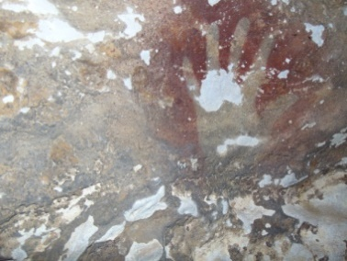
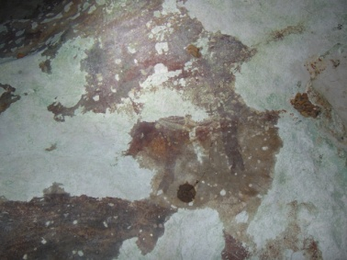
Figure 5. Situation on Panel Number 2

Room 2 in the middle has traces of panel paintings whose images have not been identified, then there are 4 negative handprints that appear close together. Furthermore, on the left side of this room there is a panel which still has a vague image of a pig with 2 tails facing each other and 4 negative handprints in irregular positions. In room 3, passing through a narrow gap in the ceiling on the left, there is a panel that looks vaguely like a painting of 2 pigs and 4 negative handprints.
Room 4 also has to pass through a narrow gap on the left side of the ceiling. You can see 1 positive foot print and in another part there is a panel with 6 hand prints, the next panel has 2 hand prints and 1 single hand print.

Room 5 is on the top floor at a height of 40 meters, you have to pass through a narrow gap rising from the ceiling of room 2 . The second floor is above the first floor with a height of about 9 meters from the first floor, this floor can be reached through the hole in the ceiling of the first floor by climbing using the SRT (Single Rope Technique) technique with a slope of about 90 degrees, the hole in the sky -The ceiling is not too wide with a width of about 60 cm and a length of about 1 meter.

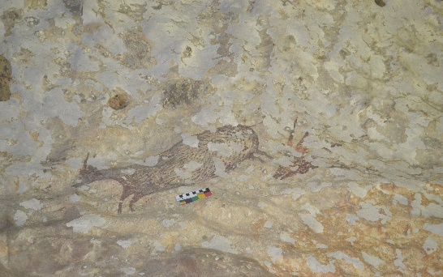
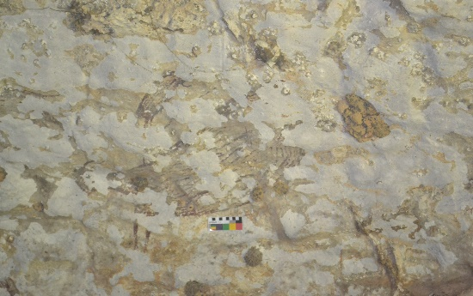
Figure 6 : Left Photo. Painting of Waterpig in big and small size, Right Photo. Anoa Painting

The orientation of the cave mouth faces east (90 ⁰) with a width of about 1.6 meters and a height of about 3 meters, has one room in the form of a semi-circular tunnel with tunnel directions southwest and east, on the left and right sides there is a terrace with a height of about 180 cm from the surface of the cave floor, the two terraces are not very wide with an area of around 1 meter from the cave wall. The surface of the cave floor is quite flat and in the middle, there are flat, bolder-sized limestone fragments. The intensity of light on the front is quite good, while on the inside it is less so the room is quite dark and damp. On the inside there are quite a lot of ornaments in the form of stalactics. decorating the walls, based on observations made it is possible that the inside of the cave used to be a door that had been covered by cave ornaments.
The potential cultural heritage contained in this cave is a wall painting consisting of one panel with the painting positioned on the left side of the cave, precisely on the wall of the first terrace. The painting has been damaged but can still be identified, based on the results of observations, the painting consists of a Deer and a Pig. Anoa consists of two sizes, namely large and small.

Acknowledgements (optional)
We acknowledge the support received from Cultural Preservation Agency Office of Region IX.

References and/or Bibliography
Ahmad, A., & Hamzah, S. (2016). South Sulawesi Karst Database. Makassar: Regional Environmental Agency of South Sulawesi Province. Pg . 7.

Anonymous. (2011). Delineation of the Maros-Pangkep Karst Prehistoric Cave Cultural Heritage Area. Makassar: South Sulawesi Cultural Heritage Conservation Center. Pg . 48-50.

Anonymous. (2019). Technical Study Report for the Development of Prehistoric Caves Sites in Maros Regency. Makassar: South Sulawesi Cultural Heritage Conservation Center. Pg . 1.

Anonymous. (2021). Exploration Report on New Caves in Maros Regency and Pangkep Regency. Makassar: South Sulawesi Province Cultural Heritage Conservation Center.

Irwansyah, E. (2013). GEOGRAPHIC INFORMATION SYSTEMS: Basic Principles and Application Development. Yogyakarta: Digibooks. Pg . 4.

W. Mehrer, M., & L. Wescott, K. (. (2006). GIS and Archaeological Site Location Modeling. CRC Press. Pg . 200-203.
Ahmad, A., & Hamzah, AS (2016). South Sulawesi Karst Data Base . https://ksdae.menlhk.go.id/assets/publikasi/Laporan_Karst_Lengkap1.pdf

Aubert, M., Brumm, A., Ramli, M., Sutikna, T., Saptomo, EW, Hakim, B., Morwood, MJ, Van Den Bergh, GD, Kinsley, L., & Dosseto, A. ( 2014). Pleistocene cave art from Sulawesi, Indonesia. Nature , 514 (7521). https://doi.org/10.1038/nature13422

Aubert, M., Lebe, R., Oktaviana, AA, Tang, M., Burhan, B., Hamrullah, Jusdi, A., Abdullah, Hakim, B., Zhao, J., Geria, IM, Sulistyarto, PH , Sardi, R., & Brumm, A. (2019). Earliest hunting scene in prehistoric art. Nature , 576 (7787), 442–445. https://doi.org/10.1038/s41586-019-1806-y

Brumm, A., Oktaviana, A. A., Burhan, B., Hakim, B., Lebe, R., Ririmasse, M., Sulistyarto, P. H., Macdonald, A. A., & Aubert, M. (2021). Do Pleistocene rock paintings depict Sulawesi warty pigs (Sus celebensis) with a domestication character? Archaeology in Oceania, 56(3). https://doi.org/10.1002/arco.5245

Dell’Unto, N., & Landeschi, G. (2022). Archaeological 3D GIS. In Archaeological 3D GIS. https://doi.org/10.4324/9781003034131

Esri. (2020). ArcGIS Online Implementation Guide | Esri . https://www.esri.com/content/dam/esrisites/id-id/media/pdf/implementation-guides/implement-arcgis-online.pdf

Goodchild, M. F. (2010). Twenty years of progress: GIScience in 2010. Journal of Spatial Information Science , 1 (2010). https://doi.org/10.5311/JOSIS.2010.1.2

Hua, A. K. (2015). Geographic Information Systems (GIS): An introduction to the computer perspective. Geografia : Malaysian Journal of Society and Space , 11 (1).

Lock, G., & Pouncet, J. (2017). Spatial thinking in archaeology: Is GIS the answer? Journal of Archaeological Science , 84 . https://doi.org/10.1016/j.jas.2017.06.002

Rangkuti, N. (2000). Archaeological Information System. Archaeological Periodicals , 20 (1). https://doi.org/10.30883/jba.v20i1.807.

Worboys, M. F., & Duckham, M. (2004). GIS A Computing Perspective . CRC Press. https://doi.org/10.4324/9780203481554

